The Swansway Gingerbread Enterprise Challenge
Phase 2: October - November, 2021

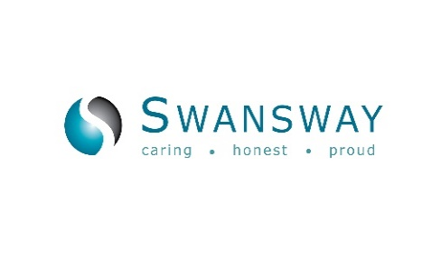
Are you an aspiring Alan Sugar or a budding Bill Gates? Have you got a group of entrepreneurs waiting to pitch their latest idea? Are you looking for something to shake off the effects of lockdown? If so, The Swansway Gingerbread Enterprise Challenge could be for you!
It is the perfect way to turn your ideas into cash, whilst at the same time helping and supporting homeless families in Stoke-on-Trent and the surrounding area.
The premise for the Swansway Gingerbread Enterprise Challenge is really, really simple. We’ll give you £50 seed money (available now) and you’ll have until 12th November, 2021 to turn it into as much money as you can! Ideally, we would like to see that £50 become at least £250!
As long as it’s safe, legal and ethical, there are no limits as to how you grow your cash. It’s a great way to get people working together as a team, develop creativity and entrepreneurial skills and have loads of fun. The only restriction is that there can only be a maximum of 6 people in a team. You could even have a bit of friendly competition with your friends and colleagues by getting a few teams to compete against each other to see who can raise the most money.
Here are a few ideas to get you started:
- Use the seed money to buy some fantastic raffle prizes and then simply hold an office raffle either weekly or as a one-off.

- Buy tubes of Smarties and hand them out to friends and colleagues and once they have eaten the contents, ask them to refill the tubes with 20 pence coins.

- Use the seed money to buy supplies for a BBQ and charge people to come along. You could also hold a raffle at the event to raise further funds.

- Buy the ingredients to bake some cakes and hold a bake sale at work, either as a one off or weekly during the Challenge.

- Set up and stock a tuck shop and have it open over the period of the Challenge.

You can reinvest the money as it grows. It’s what you have raised by the end of the Challenge that is important and hopefully you will have grown your £50 into at least £250! Be as creative as you want but just be safe, legal and ethical! There will be prizes for the most successful team and the most innovative.

To register your interest or book a team place or places, which will be limited, please contact Chris Belyavin, Fundraiser at The Gingerbread Centre by ‘phoning: 07889 565265 or email: chris.belyavin@gingerbreadcentre.co.uk

Thank you Swansway Group, Crewe, Cheshire (www.swanswaygarages.com) for their very kind sponsorship of this event.

